CBT Message Queue’s Programs Specifications

1、Summary:
The Transport Link MQ (Message Queue) process programs contain the Java classes that convert data, which receive from the IBM MQSeries5.1, to store into Transport Link database. IBM’s MQSeries classes for Java (includes ibm-mqjms.jar, ibm-mq.jar ibm-jms.jar), and Oracle’s xmlparserv2.jar are the cornerstone of These JavaBeans receiving and parsing XML data. Parsed data stores into Transport Link database through invoked Transport Link classes’ method.

2、Request and Design
Transport Link uses IBM MQSeries as MS middleware to receive and process data that come from another system of LINE. These programs are designed to provide MQ data and converting and storing. It is important that received data format must accord with standard.
According request, Design and provide the following classes:
- By a system properties configuration document, Transport Link defines configuration Message Queue.
- By CBTXMLProcess class encapsulates XML data process method.
- By CBTXMLConstant class defines some XML datas must be unified.
- By CBTParser class parse XML data.
- By ConfigManager class implements loading properties from configuration file.
- By LogManager class implement MQ events log
- By CBTMQListener class provides listener which listen MQ message events and invokes corresponded methods.
- By CBTMessageSet class implements starting CBTMQListener thread as a monitor.

3、Package and Classes
package : com.cbtb.mq
Classes :
CBTMessageSet
CBTMQListener
CBTParser
CBTXMLConstant
CBTXMLProcess
ConfigManager
LogManager
Properties file：
system.props

5、Work flow chart
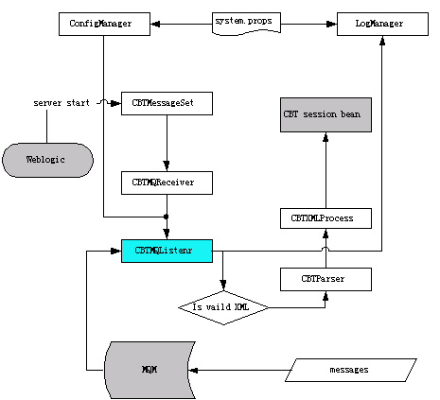
Transprot Link MQ Process Programs work flow chart
In the properties file of Weblogic configuration, add the CBTMessageSet class as a weblogic.system.startupClass. When web server service starts up, the application automates the startup of a monitor to listen messages of MQ. As soon as message data is coming, monitor trigger relevant events to process these messages, and log these process into log file.

5、Program specification:

1) All MQ Process Program classes relations overview:
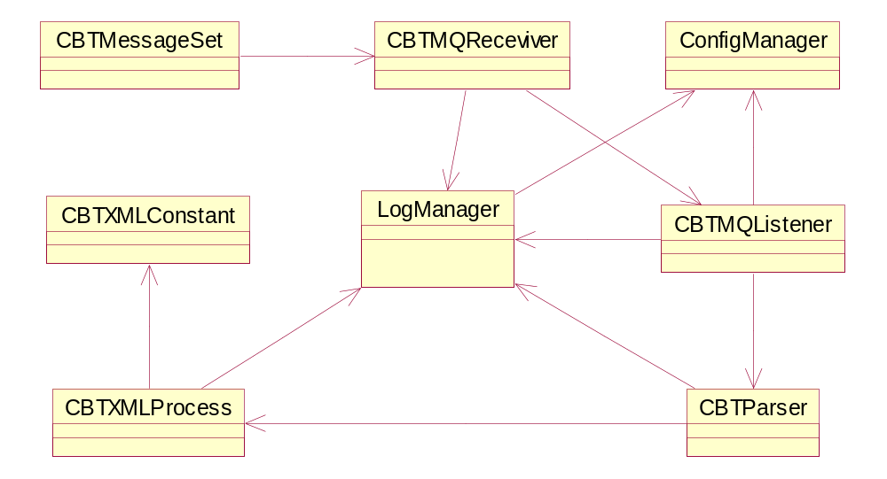
Classes’ relations UML chart

2) The Java Classes specification:
CBTMessageSet
This class is a application to start receive thread as a MQSeries message monitor. The primary methods:
public static void main(): create a CBTMessageSet object and invokes startMQThread();
public void startMQThread(): Start a CBTMQReceviver thread for listening MQSeries message.
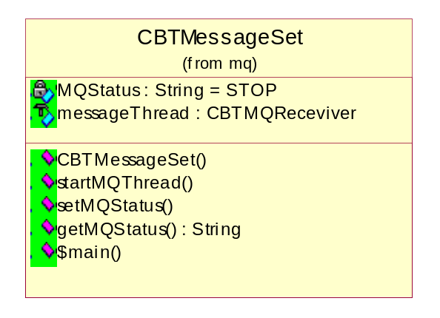

CBTMQReceviver
The class is a thread that invokes CBTMQListener to listen MQSeries. The primary method:
public CBTMQReceviver(int d): Create a CBTMQListener object as the thread run object. The parameter int d is delay time.
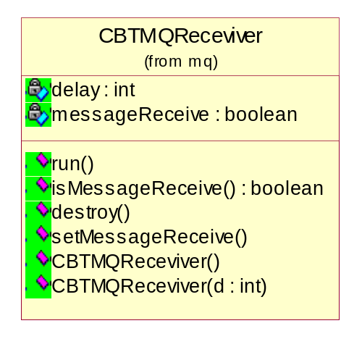

CBTMQListener
This class is a MQSeries message monitor, which contains connecting MQ, Message receive trigger, and dealing with message data. The primary methods:
public void startService(): Start listener service.
public void onMessage (Message message ) : Message trigger. When message have been received by MQ, listener would trigger the method. Then this method invokes dealMessage(String receivedMessage) to deal with received messages.
public void dealMessage(String receivedMessage):Log received messages and deal with them. Use the class CBTParser’s method , CBTParser(String XMLSource) to parse received messages.
public void onException(JMSException exception): On exception , Try to reconnect. over 30 times.
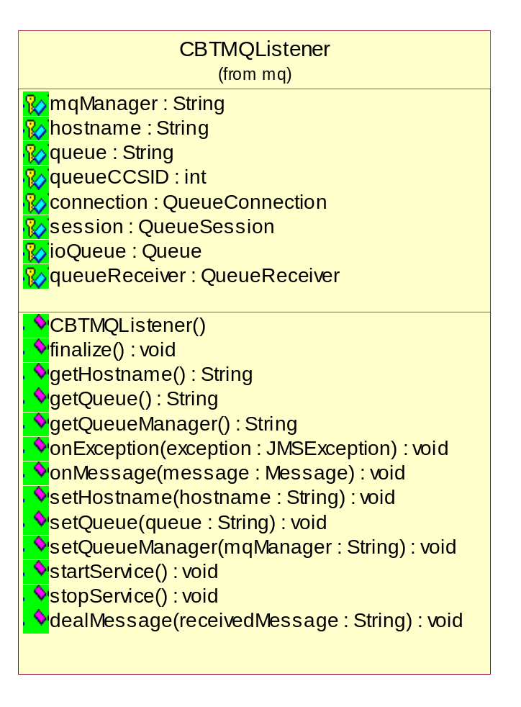

CBTParser
This class is a parser for parsing XML data that comes from MQ. The class uses Oracle XML SAX parser. The primary methods:
public boolean CBTParser(String XMLSource): Parse received messages.
public void startElement(String name ,AttributeList atts): Trigger on start of SAX parse element.
public void endDocument() : Trigger on end of SAX parse document. Invoke cbtXMLProcess.addIntoDB() store received messages from MQ to database.
public void endElement (String name) : Trigger on end of SAX parse element
public void characters(char[] cbuf,int start,int len): Trigger on SAX parse element content.
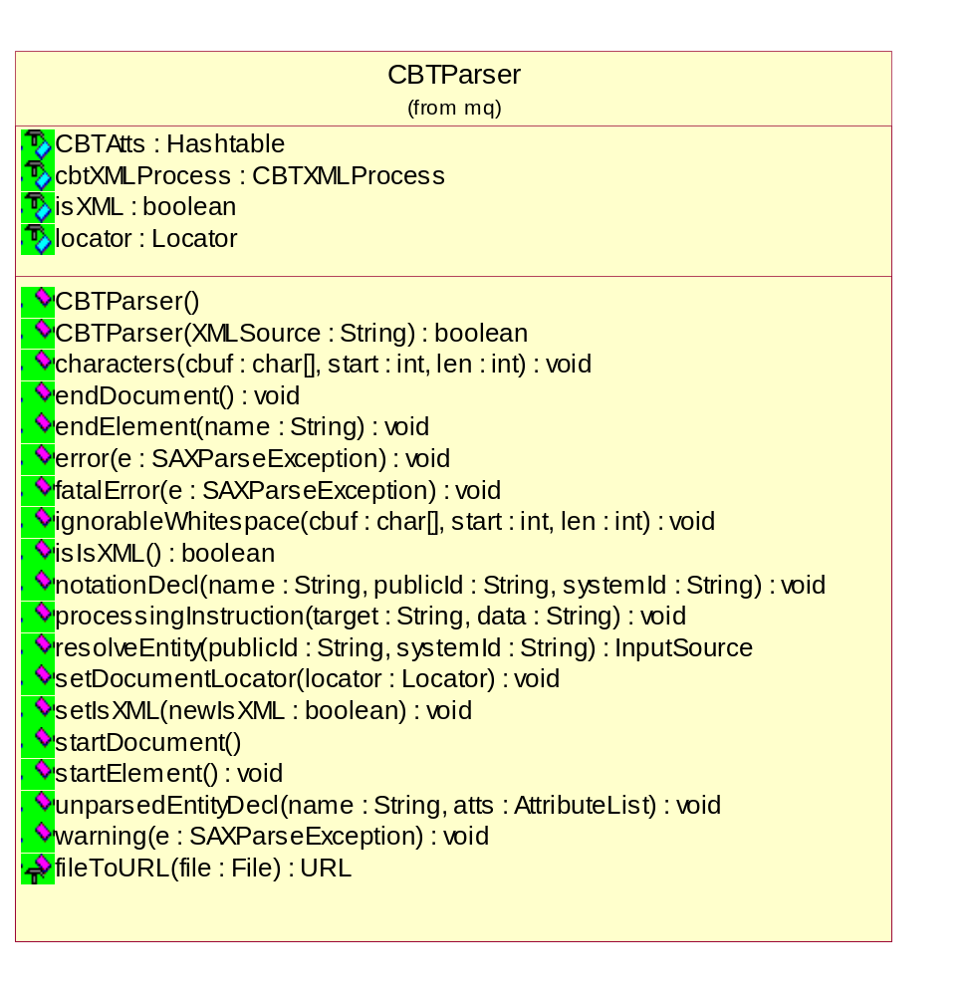

CBTXMLConstant
This class defines some constants for confirming XML datas must be unified. Includes the following constants:
public static final String ORGANISATION_TYPE_SHIPPER="Shipper";
public static final String ORGANISATION_TYPE_TRUCKER="Trucking Company";
public static final String ORGANISATION_PERFER_LANGUAGE_CN ="CN";
public static final String ORGANISATION_PERFER_LANGUAGE_EN ="EN";
public static final String ORGANISATION_STATUS_PENDING="PENDING";
public static final String ORGANISATION_STATUS_ACTIVATE="ACTIVATE";
public static final String ORGANISATION_STATUS_APPROVED ="APPROVED";
public static final String ORGANISATION_STATUS_REJECTED="REJECTED";
public static final String ORGANISATION_PAYMENT_TERMS_CASH="COD";
public static final String ORGANISATION_PAYMENT_TERMS_CREDIT="CT";
public static final String REGISTRATION_CHANNEL_INTERNET = "internet";
public static final String REGISTRATION_CHANNEL_EMAIL = "email";
public static final String REGISTRATION_CHANNEL_FAX = "fax";
public static final String REGISTRATION_CHANNEL_PHONE = "phone";
public static final String USER_GROUP_ID_ADMIN="OrgAdminGp";
public static final String USER_GROUP_ID_OPREATOR="OrgOpreatorGp";
public static final String ACTION_CREATE = "create";
public static final String ACTION_DELETE = "delete";
public static final String ACTION_CHANGE = "change";
public static final String ACTION_SUSPEND = "suspend";
public static final String ACTION_ACTIVE = "active";
public static final String DTD_NAME_ORAGNISATION="organisation.dtd";
public static final String DTD_NAME_TRUCKER="trucker.dtd";
public static final String DTD_NAME_USER_GROUP="user_group.dtd";
public static final String DTD_NAME_USER_PROFILE="user_profile.dtd";
public static final String DATE_FORMAT="yyyy-MM-dd";

CBTXMLProcess
This class encapsulates XML data process. The primary methods:
public boolean addIntoDB():A method to insert or update receive and parsed XML information into DB .In the part ,used some our EJB methods.
public java.util.Hashtable getCBTValueList(): Get Hashtable have been converted
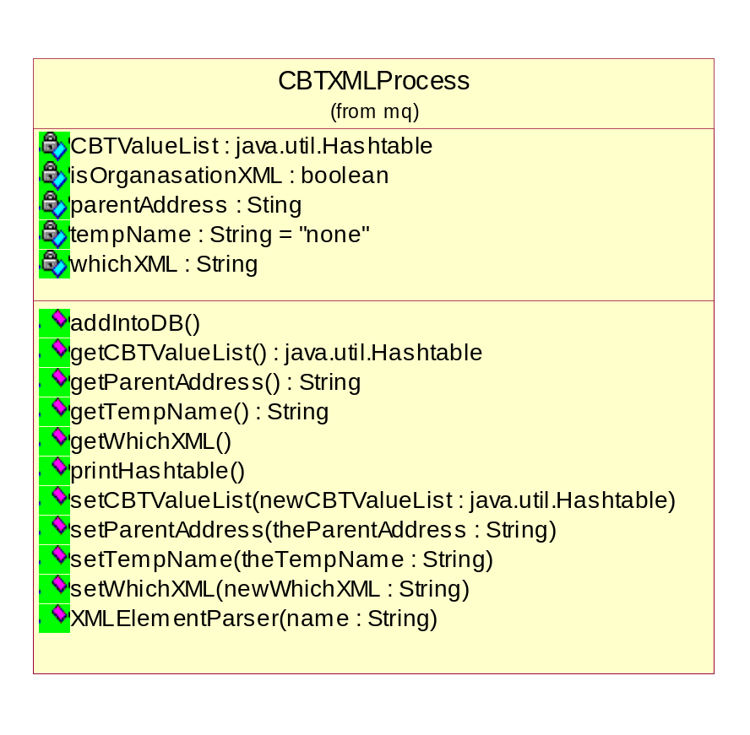
ConfigManager
This class is a configuration manager. Use it implement loading properties from configuration file, such as MQ server host name(com.cbtb.mq.queuehost), MQ manager name(com.cbtb.mq.queuemg),message receive queue name（com.cbtb.mq.inqueuename）, message listen queue name(com.cbtb.mq.listenqueue) and etc.
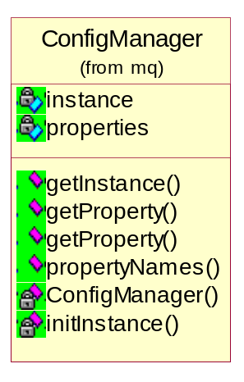
LogManager
This class implement MQ events log, Properties of log is defined at system.props file. Use ConfigManager to load them.
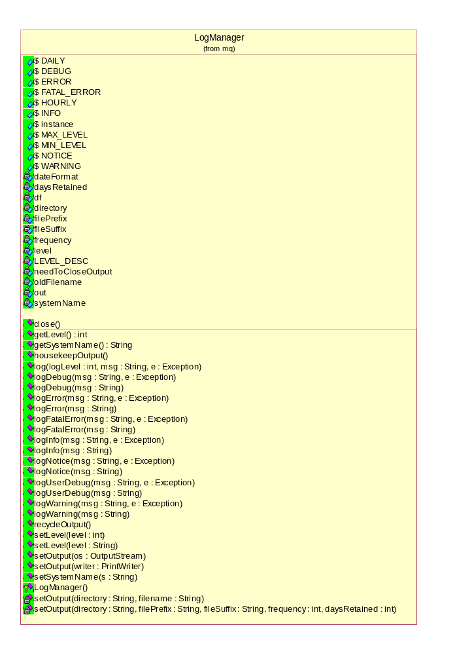
6、Remark
The programs write and test by Henry Mei.

HutchTech
2001-6-18

